Object oriented modeling and design
Model Question Paper
1. Describe object modeling.
A model is an abstraction of something for the purpose of understanding it before building it. It is easier to manipulate than the original entity. An object model captures the static structure of a system, relationships between the objects, the attributes and operations that characterize each class of objects.This model is the most important of the three models. Some basic concepts in object modeling are classes,objects, Object Diagrams,attributes, Operations and methods.

2. Explain link attributes and role names.
Link attribute
- A link attribute is a property of the links in an association.
- The OMT notation for a link attribute is a box attached to the association by a loop
- Eg: access permission is an attribute of ‘Accessible by’.
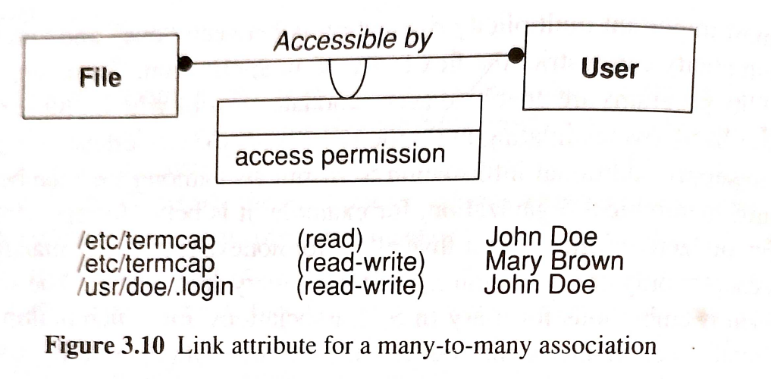
Role name
- A role is an end of an association.
- Role name is a name that uniquely identifies one end of an association.
- Eg: - “Person works for a Company.”
Here the person plays the role of an employee and the company the role of the employer
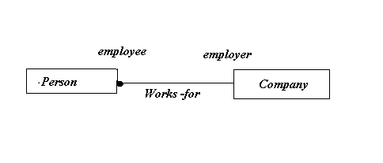
3. What is an event and state?
Event
- An event is something that happens at a point in time.
- We can understand an event as some action oriented result, such as mouse click. Whenever you will click on a mouse, the appropriate action takes place.
- An event has no duration
State
- A state corresponds to the interval between two events received by an object. Event represents points in time ; states represent interval of time.
- For example, after the receiver is lifted and before the first digit is dialed, the phone line is in state dial tone.
- A state has duration. It occupies an interval of time.
A state is often associated with a continuous activity such as the ringing of telephone or an activity that takes time to complete
4. Explain nested state diagram.
A nested state diagram is used to model the complex system as the regular state diagram is inadequate in describing the large and complex problem. A complex system has much redundancy and this redundancy can be resolved by restructuring the complex system. One method to restructure complex system is to expand the state that has certain sub states.

5. Explain how subsystems are allocated to processors and tasks
Each concurrent system must be allocated to a h/w unit-general purpose processor or a specialized functional unit.
1.Estimating Hardware Resource Requirements
2.Hardware/Software Tradeoffs
3.Allocating Tasks To Processors
4.Determining Physical Connectivity

6. How data stores are managed in a system?
• The internal and external data stores in a system provide clean separation points between subsystems with well defined interfaces.
• Data stores may combine data structures, files, and database implemented in memory or on secondary storage devices.
• The different data stores provide trade-offs between cost, access time, capacity and reliability.
• Files are cheap, simple and permanent form of data store.
• File operations are low level and applications must include additional code to provide a suitable level of abstraction.
• File implementations vary from machine to machine so portability is more difficult.
• Databases are powerful and make applications easier to port.
• Databases do have a complex interface and may work awkwardly with programming languages.
7. Describe fundamental concepts of the object-oriented world.
- Objects
  - An object is an instance of a class that represents a specific entity in the real world. Objects have attributes (data) and behaviors (methods) that define what they are and what they can do.eg: In a software system for a library, a "Book" could be an object with attributes like title, author, ISBN, and behaviors like checkout() or return().
- Classes
  - A class is a blueprint or template for creating objects. It defines the attributes and methods that the objects instantiated from the class will have.eg: The "Book" class would define the structure and behavior for all books in the library system.
- Attributes
  - Attributes are the data elements that describe the properties of an object. They represent the state of an object.eg: For the "Book" class, attributes might include title, author, ISBN, and availability.
- Methods
  - Methods are functions defined within a class that describe the behaviors of an object. They allow objects to interact with other objects and modify their own attributes.Eg: The checkout() method might update the availability attribute of a "Book" object.
- Relationships
  - Relationships define how objects interact with one another. Common types include associations, inheritance, and aggregation.Eg: In the library system, a "Member" class might have an association with the "Book" class, indicating which books a member has checked out.
- Inheritance
  - Inheritance allows a new class to inherit attributes and methods from an existing class, promoting code reuse and creating hierarchical relationships.Eg: A "ReferenceBook" class could inherit from the "Book" class but have additional attributes or methods specific to reference books.

8. Explain Unified Modeling Language (UML).
Unified Modeling Language (UML) is a standardized visual modeling language used in the field of software engineering to provide a general-purpose, developmental, and intuitive way to visualize the design of a system. UML helps in specifying, visualizing, constructing, and documenting the artifacts of software systems.UML defines nine types of diagrams: Class (package), Object, Use case, Sequence, Collaboration, State chart, Activity, Component, and Deployment
In Class diagrams, classes are depicted as boxes, each containing three compartments for the class name, attributes, and methods. Lines connecting classes illustrate associations, showing relationships such as one-to-one or one-to-many. Class diagrams provide a high-level overview of a system’s design, helping to communicate and document the structure of the software.Object diagrams in UML are depicted using a simple and intuitive notations to show a snapshot of a system at a specific point in time, displaying instances of classes and their relationships.Use Case Diagrams are used to depict the functionality of a system or a part of a system. They are widely used to illustrate the functional requirements of the system and its interaction with external agents(actors). A sequence diagram simply depicts interaction between objects in a sequential order i.e. the order in which these interactions take place. Collaboration diagram visually represents the interactions between objects or components in a system, showing how they collaborate to accomplish tasks or scenarios and depicts the interconnections among multiple objects within a system, illustrating the system’s object architecture.A state diagram is used to represent the condition of the system or part of the system at finite instances of time. It’s a behavioral diagram and it represents the behavior using finite state transitions.

9. What are use cases and actors? Explain the use case diagram for an entry substystem
1. Use Cases:
- A use case represents a specific functionality or goal that a system must accomplish. It describes a scenario or sequence of interactions between the system and its users (or other systems) to achieve a particular outcome.
- Use cases are often defined at varying levels of granularity, from high-level goals (e.g., "Process Payment") to specific tasks (e.g., "Validate Credit Card").
- They capture the system's functional requirements and are often expressed in terms of what the system should do, rather than how it should do it.
2. Actors:
- An actor is any entity that interacts with the system in some way, typically by initiating or participating in a use case. Actors are not part of the system itself but represent roles that users (or external systems) play in the interaction with the system.
Use Case Diagram for an Entry Subsystem:
A Use Case Diagram visually represents the relationships between actors and use cases in a system. It is part of the Unified Modeling Language (UML) and is used to depict the system's functional requirements.
For an Entry Subsystem (e.g., a system that manages access control to a building or restricted area), the use case diagram might include the following elements:
Actors:
- Visitor: Someone who needs temporary access to the building.
- Employee: Someone who requires regular access to the building.
- Security Officer: Someone responsible for overseeing access and managing exceptions.
- Admin: Someone responsible for managing access rights and user data.
Use Cases:
- Request Access: The visitor or employee requests access to the building (e.g., via a keycard or biometric system).
- Grant Access: The system validates the user's credentials and grants access if they are authorized.
- Deny Access: The system denies access if the user is unauthorized or their credentials are invalid.
- Manage Access Rights: The admin adds, modifies, or deletes access rights for users.
- Override Access: The security officer can manually override the system to grant or deny access in special circumstances.
- Generate Access Reports: The system generates logs or reports on who accessed the building and when.
Diagram Layout:
- System Boundary: A rectangle representing the entry subsystem.
- Use Cases: Ovals inside the system boundary, representing different use cases such as "Request Access," "Grant Access," and "Manage Access Rights."
- Actors: Stick figures outside the system boundary representing actors like "Visitor," "Employee," "Security Officer," and "Admin."
- Associations: Lines connecting actors to the relevant use cases, indicating interaction.

10.Mention the purpose of use case diagram.
Use case diagrams model the functionality of a system using actors and use cases. Use cases are services or functions provided by the system to its users.A Use Case Diagram is a vital tool in system design, it provides a visual representation of how users interact with a system. It serves as a blueprint for understanding the functional requirements of a system from a user’s perspective, aiding in the communication between stakeholders and guiding the development process. A Use Case Diagram is a type of Unified Modeling Language (UML) diagram that represents the interaction between actors (users or external systems) and a system under consideration to accomplish specific goals. It provides a high-level view of the system’s functionality by illustrating the various ways users can interact with it.

11. Describe the various stages involved in the object-oriented methodology.
The object-oriented methodology has the following stages:
- Analysis
- System design
- Object design
- Implementation
Analysis
- An analysis model is a concise, precise abstraction of what the desired system must do, not how it will be done.
- It should not contain any implementation decisions.
- The objects in the model should be application domain concepts and not the computer implementation concepts(datastructures).
System design
- The designer makes high level decisions about the overall architecture.
- In system design, the target system is organized as various subsystems based on both the analysis structure and the proposed architecture.
Object design
- The designer builds a design model based on the analysis model but containing implementation details.
- The focus of object design is the data structures and algorithms needed to implement each cycle.
Implementation
- The object classes and relationships developed during object design are finally translated into a particular programming language,database,or hardware implementation.
- During implementation, it is important to follow good software engineering practice so that the system can remain the traceability, flexibility and extensibility.

12. Explain in detail about the three types of object-oriented models.
The OMT methodology uses three kinds of models to describe a system.
  - Object Model
  - Dynamic Model
  - Functional Model
Object Model
  - Describes the static structure of the objects in a system and their relationships.
  - Main concepts are classes and associations, with attributes and operations.
  - Aggregation and generalization are predefined relationships
  - This model mainly contains object diagrams.
  - An object diagram is a graph whose nodes are object classes and whose arcs are relationships among classes.
Dynamic Model
  - The dynamic model describes the aspects of a system that change over time.
  - It is used to specify and implement the control aspects of a system
  - It represents a state/transition view on the model.
  - Main concepts are states, transitions between states and events to trigger transitions.
  - Actions can be modeled as occurring within states.
  - This model contains state diagrams.
  - A state diagram is a graph whose nodes are states and whose arcs are transitions between states caused by events.
Functional Model
-Describes the data value transformations within a system.
  - Main concepts are process, data store, data flow, and actors.
  - This model contains the data flow diagrams
  - A data flow diagram represents a computation.
  - A data flow diagram is a graph whose nodes are processes and whose arcs are dataflows.

13.Describe process and data flows used in data flow diagrams.
Process
- A process transforms data values.
- The lowest level processes are pure functions without side effects.
- An entire data flow graph is a high level process.
- A process may have side effects if it contains nonfunctional components
- A process is drawn as an ellipse containing a description of the transformation(name)
- Each process has a fixed number of input and output data arrows, each of which carries a value of a given type
- The inputs and outputs can be labeled to show their role in the computation, but often the type of value on the data flow is sufficient.
- Processes are implemented as methods of operations on object classes.
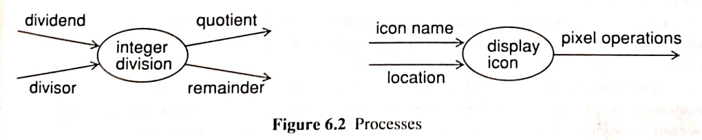
Dataflow
- A data flow connects the output of an object or process to the input of another object or process.
- It represents an intermediate data value within a computation.
- The value is not changed by the flow.
- A data flow is drawn as an arrow between the producer and the consumer of the data value.
- The arrow is labelled with a description of the data( name or type.)
- A fork with several arrows emerging from it indicates that the same value can be sent to several places.
- The output arrows are unlabeled because they represent the same value as the input
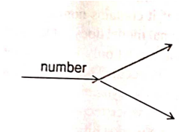

14. Design a dynamic model with a suitable state diagram for an ATM machine showing various states and events.
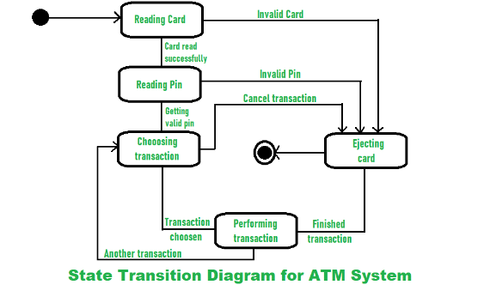
When the customer inserts the bank or credit card in the ATM’s card reader, the entry action i.e read card is performed by the ATM machine. If the card is not valid then the machine will perform exit action. After the card is being read successfully, the ATM machine will ask for Pin. Then the customer enters the pin and ATM machine then reads pin. If the pin entered is not valid then machine will perform exit action. If the pin entered is valid, then the machine further process towards transaction. After successful transaction, machine undergoes the exit action i.e., ejectcard that discharges the customer’s card.
15. Analyze the dynamic and functional model and give a suitable design for the system.
Step 1: Dynamic Model Analysis
The dynamic model focuses on the behavior of the system, capturing how objects interact with each other over time. This includes states, events, and transitions.
Components of the Dynamic Model:
- State Diagrams:
  - Describe the possible states of an object and the transitions between those states in response to events.
  - Example: In an access control system, states could include "Idle," "Access Requested," "Verifying Credentials," "Access Granted," and "Access Denied."
- Sequence Diagrams:
  - Show the interaction between objects in a system, detailing the order in which messages are sent.
  - Example: A user interacts with the access control system, which communicates with the database to verify credentials, then grants or denies access.
- Activity Diagrams:
  - Model the workflow of activities and the conditions under which they occur.
  - Example: The process of requesting access, verifying credentials, and granting access can be modeled as a sequence of activities.
Example Dynamic Model for an Entry Subsystem:
- States:
  - Idle: Waiting for a user to initiate an action.
  - Access Requested: User submits credentials.
  - Verifying Credentials: System checks the user's credentials.
  - Access Granted: Credentials are valid, and access is allowed.
  - Access Denied: Credentials are invalid or access is restricted.
  - Override: Security officer manually intervenes to override access control.
- Transitions:
  - Idle → Access Requested: When the user initiates access.
  - Access Requested → Verifying Credentials: Credentials are submitted for verification.
  - Verifying Credentials → Access Granted: If credentials are valid.
  - Verifying Credentials → Access Denied: If credentials are invalid.
  - Access Denied → Override: Security officer manually overrides access denial.
Step 2: Functional Model Analysis
The functional model describes what the system does by focusing on the processes, data, and flow of information. The key tool here is the Data Flow Diagram (DFD).
Components of the Functional Model:
- Processes:
  - Functions or activities that the system performs.
  - Example: "Request Access," "Verify Credentials," "Grant Access," "Log Access Attempts."
- Data Stores:
  - Repositories where data is stored.
  - Example: "User Database," "Access Log."
- Data Flows:
  - Movement of data between processes, data stores, and external entities.
  - Example: Credentials flow from the user to the system for verification.
- External Entities:
  - Actors or systems that interact with the system but are not part of the system.
  - Example: Users, Security Officers, Admins.
Example Functional Model for an Entry Subsystem:
- Processes:
  - Request Access: User submits credentials for access.
  - Verify Credentials: System checks credentials against the user database.
  - Grant/Deny Access: Based on verification, access is granted or denied.
  - Log Access Attempt: The system logs all access attempts, successful or not.
- Data Stores:
  - User Database: Stores user credentials and access rights.
  - Access Log: Stores logs of all access attempts.
- Data Flows:
  - From User to Request Access: User submits credentials.
  - From Request Access to Verify Credentials: Credentials are verified against the user database.
  - From Verify Credentials to Grant/Deny Access: System decides whether to grant or deny access.
  - From Grant/Deny Access to Access Log: The outcome of the access attempt is logged.
Step 3: Design of the System
By integrating the dynamic and functional models, we can create a well-rounded design that addresses both the behavior and the functionality of the system.
Key Classes:
- User:
  - Attributes: userID, credentials, accessRights
  - Methods: requestAccess(), submitCredentials()
- AccessControlSystem:
  - Attributes: state, logs
  - Methods: verifyCredentials(), grantAccess(), denyAccess(), logAccessAttempt()
- SecurityOfficer:
  - Attributes: officerID, overridePermissions
  - Methods: overrideAccess(), monitorAccess()
- Admin:
  - Attributes: adminID
  - Methods: manageAccessRights(), addUser(), deleteUser(), modifyUserRights()
- Database (e.g., UserDatabase, AccessLog):
  - Attributes: userRecords, accessLogs
  - Methods: storeUser(), fetchUser(), logAttempt()
Interactions:
- User: Calls requestAccess(), and the AccessControlSystem transitions from Idle to Access Requested.
- AccessControlSystem: Invokes verifyCredentials() to check the user's credentials.
  - If valid, the system calls grantAccess(), and the state transitions to Access Granted.
  - If invalid, the system calls denyAccess(), and the state transitions to Access Denied.
- SecurityOfficer: Can call overrideAccess() to manually intervene, transitioning the system to the Override state.
- Admin: Manages access rights via interaction with the Database, ensuring that the system is up to date.
Overall Architecture:
- Front-End:
  - Users interact with the system through interfaces such as card readers, biometric scanners, or login screens.
- Middle Layer:
  - The AccessControlSystem handles processing, verifying credentials, granting/denying access, and logging activities.
- Back-End:
  - Databases (e.g., UserDatabase, AccessLog) store user credentials and logs of access attempts, ensuring data persistence and supporting system operations.
Example Object-Oriented Design:
- Class Diagram: Would illustrate the relationships between the classes (e.g., User, AccessControlSystem, SecurityOfficer, Admin, Database).
- Sequence Diagram: Would show how the User interacts with the AccessControlSystem, how the system verifies credentials, and how the system responds (granting or denying access).

16. Explain in detail the common architectural frameworks.
There are several prototypical architectural frameworks that are common in existing systems.
Each of these is well-suited to a certain kind of system.If we have an application with similar characteristics, we can save effort by using the corresponding architecture, or at least use it as a starting point for our design.

The kinds of system include:
1.Batch transformation – a data transformation executed once on an entire input set.
2.Continuous transformation – a data transformation performed continuously as inputs change.
3.Interactive interface – a system dominated by external interactions.
4.Dynamic simulation – a system that simulates real world objects.
5.Real time system – a system dominated by strict timing constraints
6.Transaction manager – a system concerned with storing and updating data, often including concurrent access from different physical locations
1. Batch transformation:
- It is a data transformation executed once on an entire input set.
- A batch transformation is a sequential input-to-output transformation, in which inputs are supplied at the start, and the goal is to compute an answer.
- There is no ongoing interaction with the outside world.
- The most important aspect of the batch transformation is the functional model which specifies how input values are transformed into output values.

The steps in designing a batch transformation are:
  - Break the overall transformation into stages, each stage performing one part of the transformation.
  - The system diagram is a data flow diagram. This can be taken from the functional model.
  - Define intermediate object classes for the data flows between each pair of successive stages.
  - Expand each stage in turn until the operations are straightforward to implement.
  - Restructure the final pipeline for optimization.

2.Continuous Transformation:
  - It is a system in which the outputs actively depend on changing inputs and must be periodically updated.
  - Because of time constraints, the entire set of outputs cannot usually be recomputed each time an input changes.
  - the new output values must be computed incrementally. The transformation can be implemented as a pipeline of functions.
  - The effect of each incremental change in an input value must be propagated through the pipeline.
The steps in designing a pipeline for continuous transformation are:
    - Draw a DFD for the system.
      - The input and output actors correspond to data structures whose value change continuously.
      - Data stores within the pipeline show parameters that affect the input-to-output mapping.
    - Define intermediate objects between each pair of successive stages.
    - Differentiate each operation to obtain incremental changes to each stage.
    - Add additional intermediate objects for optimization.

3. Interactive Interface:

- An interactive interface is a system that is dominated by interactions between the system and external agents, such as humans, devices or other programs.
- The external agents are independent of the system, so their inputs cannot be controlled.
- Interactive interfaces are dominated by the dynamic model.

The steps in designing an interactive interface are:
  - Isolate the objects that form the interface from the objects that define the semantics of the application.
  - Use predefined objects to interact with external agents, if possible.
  - Use the dynamic model as the structure of the program.
  - Isolate physical events from logical events.
  - Fully specify the application functions that are invoked by the interface. Make sure that the information to implement them is present.

4.Dynamic Simulation:

- A dynamic simulation models or tracks objects in the real world.
- The steps in designing a dynamic simulation are:
  - Identify actors, real-world objects from the object model-the actors have attributes that are periodically updated.
  - Identify discrete events. Discrete events correspond to discrete interactions with the object and can be implemented as operations on the object.
  - Identify continuous dependencies.
  - Generally a simulation is driven by a timing loop at a fine time scale. Discrete events between objects can often be exchanged as part of the timing loop.

5.Real Time System:

- Real Time System is an interactive system for which time constraints on actions are particularly tight or in which the slightest timing failure cannot be tolerated.

6.Transaction Manager:
- A transaction manager is a database system whose main function is to store and access information.
- The information comes from the application domain.
- Most transaction managers must deal with multiple users and concurrency.
- The steps in designing a transaction management system are:
  - Map the object model directly into a database.
  - Determine the units of concurrency. Introduce new classes as needed.
  - Determine the unit of transaction.
  - Design concurrency control for transactions.

17. You have been tasked with designing a game that involves multiple players interacting with each other in a virtual environment. How would you design the objects and associations necessary to manage the game state, player interactions, and scoring? What are some potential challenges you might encounter when designing these objects and associations?
System Design for a Multiplayer Game
1. Core Components
1.1 Game Objects
- Player
  - Attributes: playerID, username, score, position, health, inventory
  - Methods: move(), attack(), collectItem(), updateScore()
- Game Environment
  - Attributes: environmentID, map, objects (e.g., obstacles, power-ups)
  - Methods: updateMap(), addObject(), removeObject(), getObjectAt()
- Game Object
  - Attributes: objectID, type (e.g., item, obstacle), position, properties (e.g., damage)
  - Methods: interact(), updateProperties()
- Game State
  - Attributes: gameID, currentRound, gamePhase (e.g., setup, in-progress)
  - Methods: startRound(), endRound(), updateState()
1.2 Associations
- Player to Game Environment
  - Association: A player interacts with and is located within the game environment.
  - Method Example: Player.move() updates Player.position in Game Environment.
- Player to Game Object
  - Association: Players can interact with game objects (e.g., picking up items, triggering events).
  - Method Example: Player.collectItem(GameObject) updates both Player.inventory and GameObject.status.
- Game Object to Game Environment
  - Association: Game objects are managed by the game environment.
  - Method Example: GameEnvironment.addObject(GameObject) manages objects within Game Environment.
- Game State to Player
  - Association: The game state keeps track of all players and their statuses.
  - Method Example: GameState.updatePlayerScore(Player) modifies Player.score.
Addressing Challenges
1. Synchronization- Ensuring that all players view a consistent game state and that changes are correctly propagated across different clients.
2. Networking Latency- Dealing with the delay between a player’s action and the corresponding update being reflected across the network. High latency can cause delays and affect the responsiveness of the game.

18. Describe the approaches to implementation of control in object design.
Implementation of Control
- The designer must refine the strategy for implementing the state – event models present in the dynamic model.
- As part of system design, you will have chosen a basic strategy for realizing dynamic model, during object design.
- There are three basic approaches to implement the dynamic model:
  - Using the location within the program to hold state(Procedure driven System)
  - Direct implementation of a state machine mechanism(Event-driven System)
  - Using concurrent tasks
1.State as Location within a Program:
- This is the traditional approach to representing control within a program.
- The location of control within a program implicitly defines the program state.
- Any finite state machine can be implemented as a program.
- Each state transition corresponds to an input statement.
- After input is read, the program branches depending on the input event received.
- Each input statement need to handle any input value that could be received at that point.
- One technique of converting state diagram to code is as follows:
  - Identify the main control path. Beginning with the initial state, identify a path through the diagram that corresponds to the normally expected sequence of events. Write the name of states along this path as a linear sequence of events.This becomes a sequence of statements in the program.
  - Identify alternate paths that branch off the main path and rejoin it later. These become conditional statements in the program.
  - Identify backward paths that branch off the main loop and rejoin it earlier .These become loops in program. If multiple backward paths that do not cross, they become nested loops. Backward paths that cross do not nest and can be implemented with goto if all else fails, but these are rare.
  - The states and transitions that remain correspond to exception conditions. They can be handled using error subroutines , exception handling supported by the language , or setting and testing of status flags. In the case of exception handling, use goto statements.
2.State machine engine
- The most direct approach to control is to have some way of explicitly representing and executing state machine.
- For example, state machine engine class helps execute state machine represented by a table of transitions and actions provided by the application.
- Each object instance would contain its own independent state variables but would call on the state engine to determine next state and action.
- This approach allows you to quickly progress from analysis model to skeleton prototype of the system by defining classes from object model state machine and from dynamic model and creating “stubs” of action routines
- A stub is a minimal definition of function /subroutine without any internal code.
- Thus if each stub prints out its name , technique allows you to execute skeleton application to verify that basic flow of control is correct.
- This technique is not so difficult.
3.Control as Concurrent Tasks
- An object can be implemented as task in programming language /operating system.
- It preserves inherent concurrency of real objects.
- Events are implemented as inter task calls using facilities of language/operating system.
- Concurrent C++/Concurrent Pascal support concurrency.
- Major Object Oriented languages do not support concurrency.

19. Using Booch’s methodology, design Bank ATM System with proper notations.
Design of the Bank ATM System:
a. Object Model (Class Diagram)
- Key Classes:
  - ATM: Represents the ATM machine.
  - Bank: Represents the bank that interacts with the ATM for transactions.
  - Account: Represents a user's bank account.
  - Card: Represents the ATM card used by the customer.
  - Transaction: Represents transactions performed at the ATM.
  - Customer: Represents the user of the ATM.
  - Receipt: Represents the receipt generated after a transaction.
- Relationships:
  - The ATM class interacts with the Bank class to validate transactions.
  - The Customer class has a relationship with the Account class.
  - The Transaction class is associated with the Account class to record details of the transactions.
  - The Card class is linked to the Account class as a card is associated with an account.
b. B. Dynamic Model (State Diagram)
- ATM States:
  - Idle: The ATM is waiting for a card to be inserted.
  - Card Inserted: The card is inserted, waiting for the customer to enter a PIN.
  - PIN Entered: The customer has entered the PIN, waiting for the bank to validate it.
  - Transaction Selection: The customer selects the transaction type (withdrawal, deposit, balance inquiry).
  - Processing Transaction: The ATM processes the selected transaction (communicates with the bank).
  - Transaction Completed: The transaction is completed, and the ATM dispenses cash or provides a receipt.
  - Eject Card: The ATM ejects the card after the transaction.
- Transitions:
  - Idle → Card Inserted: Triggered when the user inserts the card.
  - Card Inserted → PIN Entered: Triggered when the user enters the PIN.
  - PIN Entered → Transaction Selection: Triggered after successful PIN validation.
  - Transaction Selection → Processing Transaction: Triggered when the user selects a transaction.
  - Processing Transaction → Transaction Completed: Triggered when the transaction is processed by the bank.
  - Transaction Completed → Eject Card: After the transaction, the ATM ejects the card and returns to the Idle state.
c. C. Interaction Model (Sequence Diagram)
- Scenario: The customer withdraws money from their account.
- Sequence:
  - The Customer inserts the Card into the ATM.
  - The ATM asks for the PIN and validates it with the Bank.
  - The Customer selects the withdrawal option.
  - The ATM processes the transaction by interacting with the Bank to debit the Account.
  - The ATM dispenses cash and prints a Receipt.
  - The Card is ejected, and the session ends.
c. Functional Model
The functional model describes the operations that the ATM system needs to perform, usually represented through Use Case Diagrams and Activity Diagrams.
Use Case Diagram:
- Actors:
  - Customer: Uses the ATM to perform transactions.
  - Bank: Verifies transactions and maintains account balances.
- Use Cases:
  - Insert Card: Customer inserts their card.
  - Enter PIN: Customer enters their PIN for authentication.
  - Select Transaction: Customer chooses a transaction type (withdrawal, deposit, balance inquiry).
  - Process Transaction: The ATM processes the transaction with the bank.
  - Print Receipt: A receipt is generated after the transaction.
  - Eject Card: The card is ejected at the end of the session.

20.Illustrate the sequence diagram symbols and briefly explain the notations
Sequence diagrams describe interactions among classes in terms of an exchange of messages over time
Basic Sequence Diagram Symbols and Notations
- Class roles Class roles describe the way an object will behave in context.
- Use the UML object symbol to illustrate class roles, but don't list object attributes
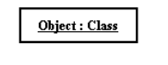
- Activation
- Activation boxes represent the time an object needs to complete a task
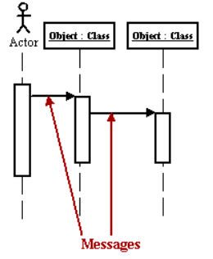
- Messages
- Messages are arrows that represent communication between objects.
- Use half-arrowed lines to represent asynchronous messages.
- Asynchronous messages are sent from an object that will not wait for a response from the receiver before continuing its tasks.
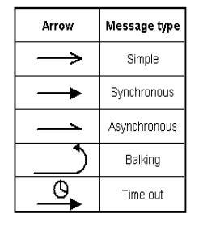
- Lifelines
- Lifelines are vertical dashed lines that indicate the object's presence over time.
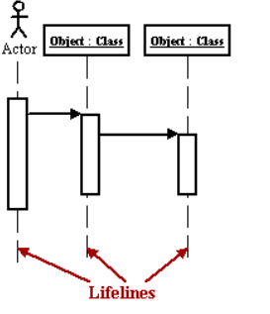
- Destroying Objects
- Objects can be terminated early using an arrow labeled "< < destroy > >" that points to an X
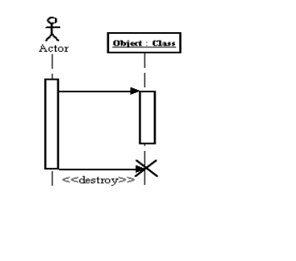
- Loops
- A repetition or loop within a sequence diagram is depicted as a rectangle.
- Place the condition for exiting the loop at the bottom left corner in square brackets [ ].
